**EXPERIMENT 2**

Q1- Create the following using HTML.

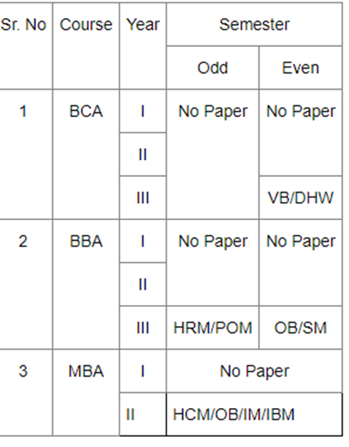

Input:-

<html>

<Title> Table </Title>

<body>

<style type="text/css">

.tg {border-collapse:collapse;border-spacing:0;}

.tg td{font-family:Arial, sans-serif;font-size:14px;padding:10px 5px;border-style:solid;border-width:1px;overflow:hidden;word-break:normal;border-color:black;}

.tg th{font-family:Arial, sans-serif;font-size:14px;font-weight:normal;padding:10px 5px;border-style:solid;border-width:1px;overflow:hidden;word-break:normal;border-color:black;}

.tg .tg-c3ow{border-color:inherit;text-align:center;vertical-align:top}

.tg .tg-0lax{text-align:left;vertical-align:top}

</style>

<table class="tg">

<tr>

<th class="tg-c3ow" rowspan="2">Sr. No</th>

<th class="tg-c3ow" rowspan="2">Course</th>

<th class="tg-c3ow" rowspan="2">Year</th>

<th class="tg-c3ow" colspan="2">Semester</th>

</tr>

<tr>

<td class="tg-c3ow">Odd</td>

<td class="tg-c3ow">Even</td>

</tr>

<tr>

<td class="tg-c3ow" rowspan="3">1</td>

<td class="tg-c3ow" rowspan="3">BCA</td>

<td class="tg-c3ow">I</td>

<td class="tg-c3ow" rowspan="3">No Paper</td>

<td class="tg-c3ow" rowspan="2">No Paper</td>

</tr>

<tr>

<td class="tg-c3ow">II</td>

</tr>

<tr>

<td class="tg-c3ow">III</td>

<td class="tg-c3ow">VB/DHW</td>

</tr>

<tr>

<td class="tg-c3ow" rowspan="3">2</td>

<td class="tg-c3ow" rowspan="3">BBA</td>

<td class="tg-c3ow">I</td>

<td class="tg-c3ow" rowspan="2">No Paper</td>

<td class="tg-c3ow" rowspan="2">No Paper</td>

</tr>

<tr>

<td class="tg-c3ow">II</td>

</tr>

<tr>

<td class="tg-c3ow">III</td>

<td class="tg-c3ow">HRM/POM</td>

<td class="tg-c3ow">OB/SM</td>

</tr>

<tr>

<td class="tg-c3ow" rowspan="2">3</td>

<td class="tg-c3ow" rowspan="2">MBA</td>

<td class="tg-c3ow">I</td>

<td class="tg-c3ow" colspan="2">No Paper</td>

</tr>

<tr>

<td class="tg-0lax">II</td>

<td class="tg-0lax" colspan="2">HCM/OB/IM/IBM</td>

</tr>

</table>

</body>

</html>

Output:-

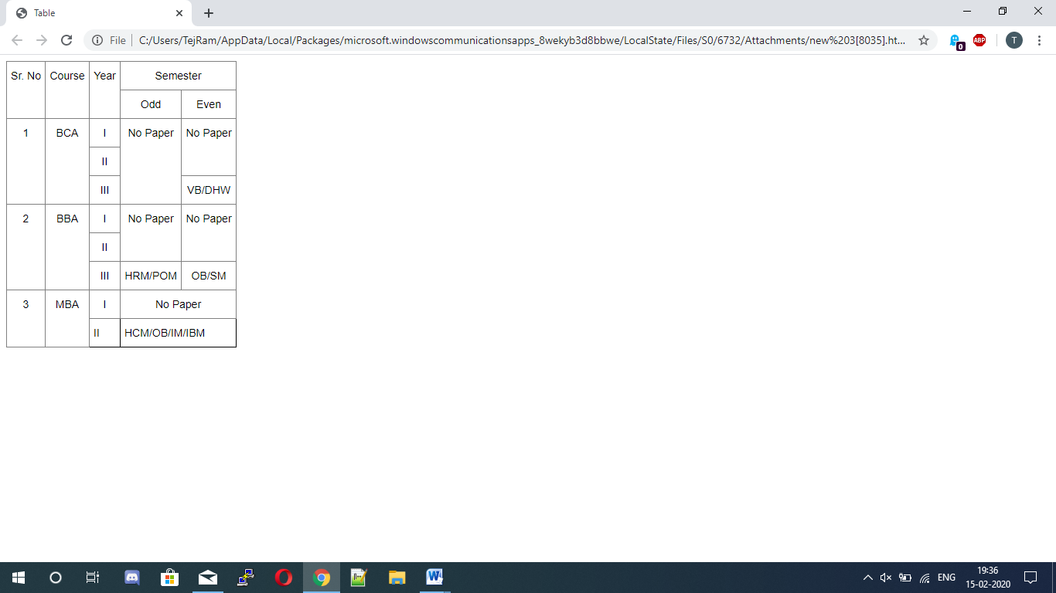

Q2- Write a HTML code to generate the following output:-

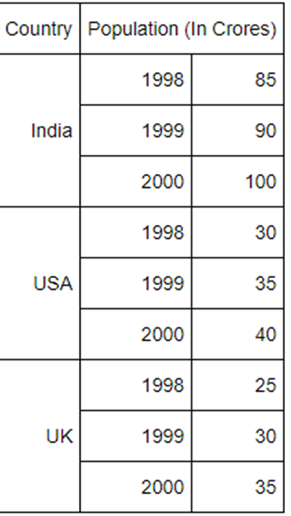

Input:-

<html>

<Title> Table </Title>

<body>

<style type="text/css">

.tg {border-collapse:collapse;border-spacing:0;}

.tg td{font-family:Arial, sans-serif;font-size:14px;padding:10px 5px;border-style:solid;border-width:1px;overflow:hidden;word-break:normal;border-color:black;}

.tg th{font-family:Arial, sans-serif;font-size:14px;font-weight:normal;padding:10px 5px;border-style:solid;border-width:1px;overflow:hidden;word-break:normal;border-color:black;}

.tg .tg-mwxe{text-align:right;vertical-align:middle}

</style>

<table class="tg">

<tr>

<th class="tg-mwxe">Country</th>

<th class="tg-mwxe" colspan="2">Population (In Crores)</th>

</tr>

<tr>

<td class="tg-mwxe" rowspan="3">India</td>

<td class="tg-mwxe">1998</td>

<td class="tg-mwxe">85</td>

</tr>

<tr>

<td class="tg-mwxe">1999</td>

<td class="tg-mwxe">90</td>

</tr>

<tr>

<td class="tg-mwxe">2000</td>

<td class="tg-mwxe">100</td>

</tr>

<tr>

<td class="tg-mwxe" rowspan="3">USA</td>

<td class="tg-mwxe">1998</td>

<td class="tg-mwxe">30</td>

</tr>

<tr>

<td class="tg-mwxe">1999</td>

<td class="tg-mwxe">35</td>

</tr>

<tr>

<td class="tg-mwxe">2000</td>

<td class="tg-mwxe">40</td>

</tr>

<tr>

<td class="tg-mwxe" rowspan="3">UK</td>

<td class="tg-mwxe">1998</td>

<td class="tg-mwxe">25</td>

</tr>

<tr>

<td class="tg-mwxe">1999</td>

<td class="tg-mwxe">30</td>

</tr>

<tr>

<td class="tg-mwxe">2000</td>

<td class="tg-mwxe">35</td>

</tr>

</table>

</body>

</html>

Output:-

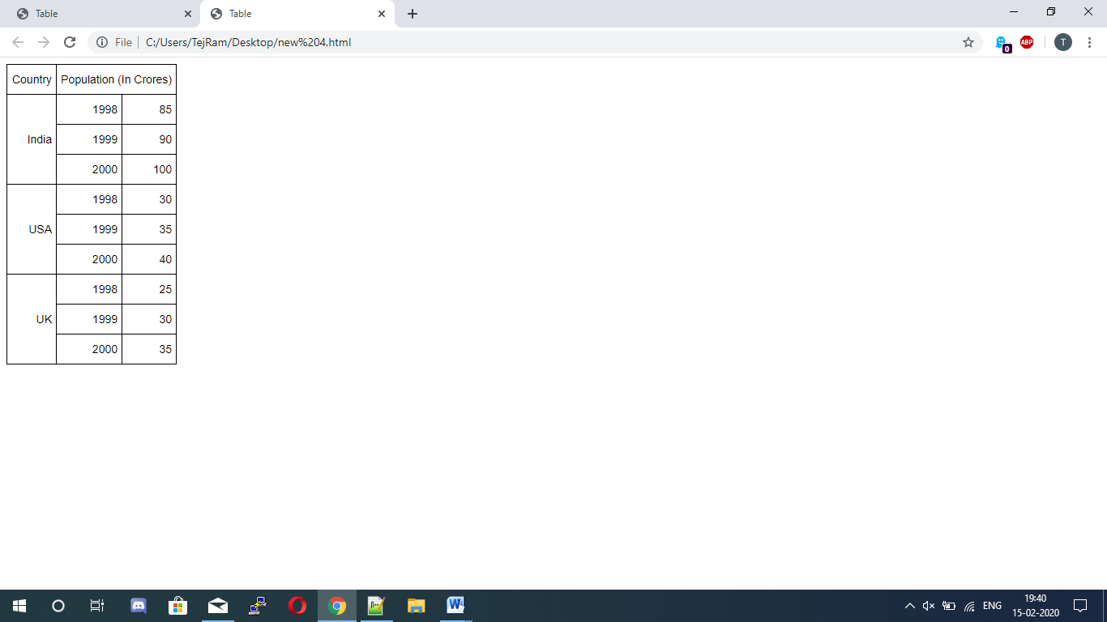

Q3- Create an HTML page containing the polynomial expression as follows:-



Input:-

<html>

<head>

<title> Polynomial Expression </title>

</head>

<body>

<H1>a<sub>0</sub> + a<sub>1</sub>x + a<sub>2</sub>x<sup>2</sup> + a<sub>3</sub>x<sup>3</sup>

</body>

</html>

Output:-

